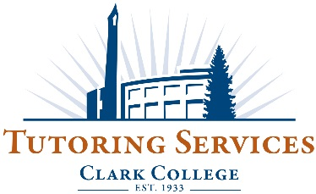

Tutoring Center Conduct
- Students utilizing tutoring services are expected to behave in accordance with the Clark College Student Code of Conduct, especially the sections outlined below.
- Students are expected to abide by any posted guidelines within the center, and follow direction given by staff on duty.
- Students are expected to contribute to a positive, healthy, and non-disruptive learning environment. Disruption, excessive noise, cell phone usage, and vulgar, inappropriate, discriminatory, or profane language are not tolerated in the centers.
- Students found in violation of these policies or the Student Code of Conduct may receive a conduct referral for further action.

Clark College Code of Student Conduct
WAC 132N-125-005 Student responsibilities. [2] Clark College expects all students to conduct themselves in a manner consistent with its high standards of scholarship and conduct. Student conduct, which distracts from or interferes with accomplishment of these purposes, is not acceptable. Students are expected to comply with these standards of conduct for students both on and off campus and acknowledge the college's authority to take disciplinary action. [3] Admission to Clark College carries with it the presumption that students will conduct themselves as responsible members of the college community. This includes an expectation that students will obey the law, comply with policies, procedures and rules of the college and its departments, maintain a high standard of integrity and honesty, and respect the rights, privileges and property of other members of Clark College. [4] It is assumed that students are and wish to be treated as adults. As such, students are responsible for their conduct.

WAC 132N-125-035 Prohibited student conduct. The college may impose disciplinary sanctions against a student who commits, or aids, abets, incites, encourages or assists another person to commit, an act(s) of misconduct which include, but are not limited to, the following:
1] Academic dishonesty. Any act of academic dishonesty including, but not limited to, cheating, plagiarism, and fabrication.
[7] Failure to comply with directive. Failure to comply with the direction of a college officer or employee who is acting in the legitimate performance of his or her duties, including failure to properly identify oneself to such a person when requested to do so.
[12] Disorderly conduct. Conduct which disrupts campus operations or the educational environment, is disturbing the peace, or assisting or encouraging another person to disturb the peace.
[13] Discriminatory conduct. Discriminatory conduct which harms or adversely affects any member of the college community….

